PCS Software Architecture Document
Version 0.2 (Iteration 2)
Draft
27 June 2026
Project: PCS

Document Control
Property | Value
Owner | Software Architect
Milestone | M1
Classification | Internal

Revision History
Version | Date | Author | Description
0.2 | 2026-06-27 | ChatGPT | Initial baseline
0.2 | 2026-06-27 | TR | Iteration 2

Table of Contents
Document Control 2
Revision History 2
1 Introduction 3
1.1 Purpose 3
1.2 Scope 5
2 System Vision 7
3 Architectural Drivers 9
4 Overall System Overview 15
Remaining Chapters (planned) 16

1 Introduction

1.1 Purpose
This Software Architecture Document defines the target architecture of the PCS Personal Content System after completion of Sprints 1–4.
The purpose of this Software Architecture Document (SAD) is to define and communicate the software architecture of the Personal Content System (PCS). It provides a comprehensive description of the system's architectural vision, guiding principles, major design decisions, logical organisation, and the relationships between its principal software components. The document serves as the authoritative reference for the architecture of PCS throughout its entire lifecycle, from initial development to future maintenance and evolution.
The primary objective of the architecture is to provide a stable and extensible foundation for a local-first platform capable of managing heterogeneous personal digital content through a unified information model. The platform is intended to support a broad range of content types—including documents, spreadsheets, presentations, electronic mail, blog posts, multimedia assets, images, travel itineraries, reviews, and future content types—while presenting them through a consistent architectural framework. Rather than implementing separate applications for each category of information, PCS adopts a unified content model in which all managed information is represented as specialised forms of a common Content Item abstraction.
This document captures both the current implementation and the target architecture towards which the project is evolving. Since PCS is being developed incrementally using an agile, sprint-based process, certain architectural capabilities described herein may be fully implemented, partially implemented, or planned for future iterations. Each major subsystem is therefore accompanied by an implementation status that allows the architecture documentation to remain aligned with the software without requiring complete revision after every sprint.
The architecture described in this document is founded on a number of key engineering principles, including:
- Clean Architecture and separation of concerns.
- Local-first operation with optional encrypted cloud synchronisation.
- Extensibility through well-defined interfaces and plug-in mechanisms.
- Security and privacy by design.
- Open standards and preference for open-source technologies.
- Test-driven development and continuous architectural documentation.
The Software Architecture Document is intended to fulfil several complementary purposes. It provides a common understanding of the system for software architects, developers, testers, administrators, and future contributors. It documents the rationale behind significant architectural decisions, thereby reducing the risk of knowledge loss over the lifetime of the project. It also establishes the framework within which future functional enhancements, technology changes, and architectural evolution can be evaluated while preserving the long-term integrity of the platform.
This document should be read in conjunction with the associated project documentation, including the Software Design Document (SDD), Architecture Decision Records (ADRs), Product Backlog, Administrator Guide, Development Guide, User Manual, and Requirements Traceability Matrix. While those documents describe implementation details, operational procedures, or project planning, this Software Architecture Document remains the definitive description of the architectural structure and guiding principles of PCS.

Architect's note
I deliberately introduced two concepts that I think will become central to the entire documentation set:
- The distinction between "current implementation" and "target architecture". This allows us to document architectural intent without implying that every capability has already been implemented.
- The concept of the SAD as the "authoritative architectural reference". I suggest we use this wording consistently throughout all future documents (SDD, Administrator Guide, ADRs, etc.), so that every document has a clearly defined role within the documentation hierarchy. This small piece of terminology will help keep the entire documentation suite coherent as the project grows.

1.2 Scope
It covers the implemented architecture (Clean Architecture, Unified Content Platform, External Import Foundation) and the planned evolution.
This Software Architecture Document defines the software architecture of the Personal Content System (PCS) and describes the architectural principles, logical organisation, major software components, interfaces, data model, technology stack, and cross-cutting concerns that collectively constitute the platform.
The scope of this document encompasses both the implemented architecture and the target architecture that guides the ongoing evolution of the system. PCS is being developed incrementally using an agile, sprint-based methodology; consequently, the architecture described herein represents a combination of currently implemented capabilities and planned architectural elements that have already been adopted as part of the long-term design vision.
At the time of publication of this version, the implemented architecture includes, among other capabilities:
- User authentication and authorisation.
- Local object storage for binary content.
- SQLite-based metadata repository.
- Clean Architecture based on Domain, Application, Infrastructure and Interface layers.
- Unified Content Platform centred around the Content Item abstraction.
- Metadata management supporting multiple content types.
- Search abstraction layer.
- Versioning metadata.
- Collections and tagging framework.
- External Import Foundation supporting future integration with external content providers.
- RESTful API exposing the platform services.
- Comprehensive automated testing based on Test-Driven Development principles.
The document also describes architectural capabilities that are planned for subsequent development iterations, including but not limited to:
- Blog management.
- Email synchronisation through external IMAP services.
- Multimedia and image management.
- Travel itinerary management.
- Optional encrypted cloud synchronisation.
- Additional search capabilities.
- Artificial Intelligence assisted services.
- Additional external import connectors.
The purpose of documenting planned capabilities is not to specify future implementation details but to ensure that the current architecture provides an appropriate foundation for their integration without requiring disruptive redesign.
This document intentionally concentrates on the software architecture of PCS. It therefore describes the structural organisation of the system, the responsibilities of its principal components, their interactions, architectural constraints, and the rationale behind significant design decisions. Detailed implementation aspects, class-level design, database schema definitions, API specifications, deployment procedures, operational guidance, and user interaction are described in the corresponding companion documents, including the Software Design Document (SDD), Administrator Guide, User Manual, API Reference, and Architecture Decision Records (ADRs).
The scope of this document explicitly excludes detailed implementation code, programming guidelines, operational procedures, installation instructions, user interface design, and sprint planning. These topics are maintained separately to allow the architecture to remain stable while implementation details evolve throughout the lifetime of the project.

Architect's note
I'd also add one sentence at the end of this section (or in §1.3) that will become useful throughout the document:
Unless otherwise stated, references to "the system" in this document refer to the Personal Content System (PCS).

2 System Vision
PCS provides a local-first platform for managing heterogeneous personal digital content through a unified content model and extensible import architecture.
The Personal Content System (PCS) is envisioned as a unified, local-first platform for the acquisition, organisation, management, preservation, and retrieval of personal digital information. Rather than focusing on a particular category of content, PCS aims to provide a single coherent environment capable of managing virtually every form of personal digital asset through a common architectural framework and a unified information model.
Modern users increasingly manage information that is fragmented across numerous specialised applications and online services. Documents are stored in office productivity suites, photographs reside in cloud storage services, electronic mail is maintained by mail providers, travel itineraries are distributed across mapping applications, multimedia is scattered across various platforms, and notes, blog posts, reviews, and other forms of information each require separate tools with independent storage mechanisms. This fragmentation leads to duplicated information, inconsistent organisation, vendor lock-in, difficulties in searching across content types, and increased dependence on third-party service providers.
PCS seeks to eliminate this fragmentation by treating all managed information as specialised forms of a common Content Item abstraction. Regardless of its origin, representation, or purpose, every managed object participates in the same architectural framework and shares a common set of metadata, lifecycle characteristics, security controls, auditing facilities, and search capabilities. This unified approach enables the platform to provide consistent functionality across heterogeneous content while allowing each content type to preserve its own specialised behaviour where appropriate.
A fundamental architectural principle of PCS is its local-first philosophy. The system is designed to operate fully on the user's own computing environment without requiring permanent connectivity to external cloud services. All metadata, configuration information, and managed content are primarily stored under the user's control. Optional synchronisation with external services may be introduced where appropriate, but such synchronisation is regarded as an enhancement rather than a prerequisite for normal operation. This approach maximises user autonomy, reduces dependence on individual service providers, improves long-term accessibility of personal information, and supports operation in environments where network connectivity is limited or unavailable.
The platform also recognises that personal information frequently originates from external systems. Rather than attempting to replace those systems, PCS provides an extensible External Import Framework through which content may be imported, catalogued, and managed while preserving complete provenance information. Every imported content item records its origin, import history, external identifiers, and associated metadata, allowing users to distinguish between information created natively within PCS and information originating from third-party platforms. This architectural approach allows the platform to progressively consolidate a user's digital assets without requiring immediate migration away from existing services.
Extensibility constitutes another key aspect of the system vision. PCS is intentionally designed as a platform rather than a fixed application. New categories of content should be incorporated through well-defined extension mechanisms without requiring architectural changes to the core platform. The Content Handler architecture enables specialised behaviour for individual content types while preserving a consistent programming model and user experience. Similarly, the External Import Framework allows additional import adapters to be introduced independently of the platform core, facilitating future integration with document repositories, cloud storage providers, email systems, social platforms, mapping services, and other information sources.
Security and privacy are considered intrinsic architectural properties rather than optional features. The platform adopts a Security by Design and Privacy by Design philosophy in which authentication, authorisation, auditing, encryption, provenance tracking, and user control over personal information are integrated into the architecture from the earliest stages of development. The system is intended to minimise unnecessary disclosure of personal information and to maximise transparency regarding the origin, lifecycle, and usage of every managed content item.
From a software engineering perspective, PCS aims to provide a maintainable, extensible, and technology-independent platform capable of evolving over many years. To achieve this objective, the architecture is founded upon established engineering principles including Clean Architecture, dependency inversion, separation of concerns, modular design, comprehensive automated testing, and continuous architectural documentation. These principles are intended to ensure that new functionality may be incorporated incrementally without compromising the overall integrity of the platform.
Although the current implementation represents only the initial stages of this vision, every architectural decision is evaluated against the long-term objective of providing a comprehensive personal information platform. The implementation roadmap includes support for additional content types, advanced search capabilities, intelligent classification, artificial intelligence assisted services, encrypted cloud synchronisation, mobile clients, collaborative features, and further integration with external information providers. The architecture described in this document is deliberately designed to accommodate this evolution while preserving backwards compatibility and protecting the long-term value of the user's information.
Ultimately, the vision of PCS is to become the user's personal digital knowledge repository: a single, coherent, extensible platform in which all personal digital information can be acquired, organised, managed, searched, preserved, and accessed independently of the applications and services from which that information originally originated.
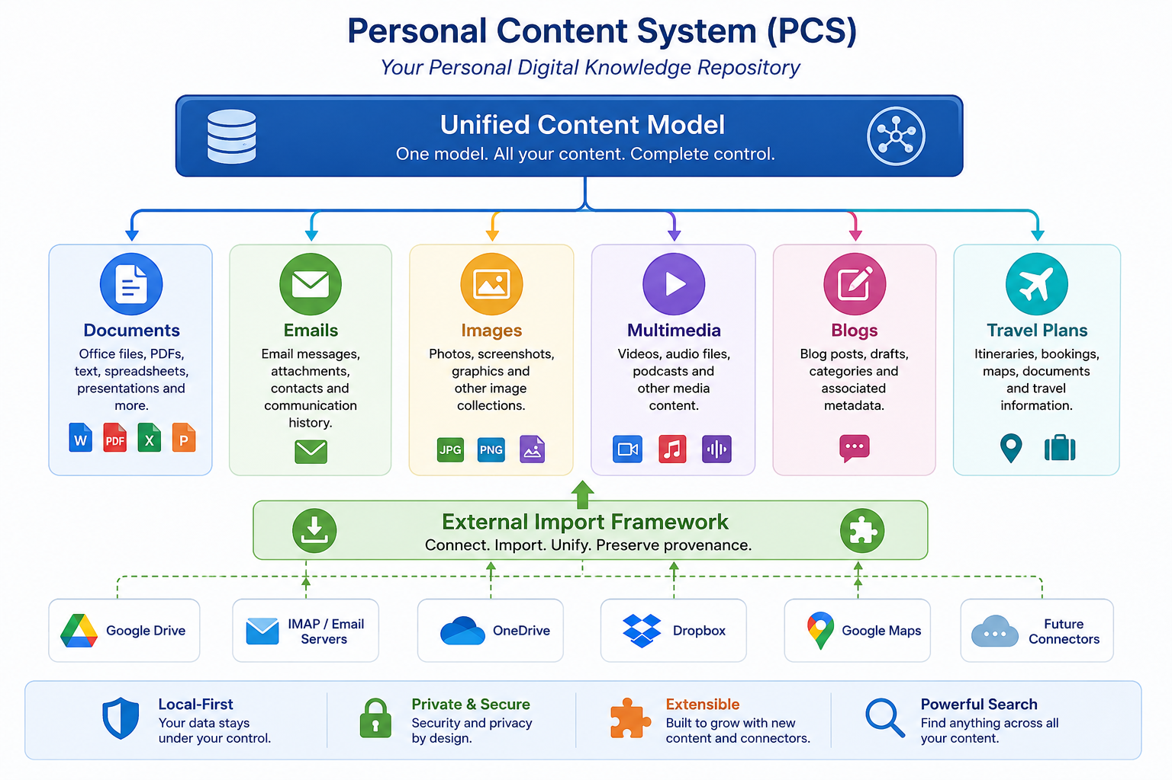

3 Architectural Drivers
- Local-first operation with optional encrypted cloud mirror.
- Python/FastAPI technology stack.
- Clean Architecture and Ports & Adapters.
- Security and privacy by design.
- Extensibility through handlers and import adapters.
- Test-driven development and living documentation.
The architecture of the Personal Content System (PCS) has been shaped by a set of architectural drivers that define the fundamental objectives, constraints, and quality attributes of the platform. These drivers represent the principal factors influencing architectural decisions throughout the development of the system and provide the criteria against which future design decisions should be evaluated.
The architectural drivers are grouped into four major categories:
- Business Drivers
- Functional Drivers
- Quality Attribute Drivers
- Technical and Implementation Constraints
Together, these drivers establish the long-term direction of the project and ensure that the architecture remains coherent as the platform evolves.
3.1 Business Drivers
3.1.1 Unified Management of Personal Digital Assets
Modern users increasingly store their personal information across numerous specialised applications and cloud services. Documents, electronic mail, photographs, videos, travel information, notes, blog posts, reviews, and other digital assets are frequently managed independently, each using its own storage model, search capabilities, metadata, and user interface.
The principal business objective of PCS is to eliminate this fragmentation by providing a single platform capable of managing heterogeneous content through a unified information model. Regardless of content type or origin, users should be able to organise, search, classify, version, and preserve their information within a consistent environment.
3.1.2 User Ownership of Information
A fundamental objective of PCS is to ensure that users retain full ownership and control of their digital information. The platform therefore adopts a local-first philosophy in which all primary data and metadata remain under the user's control. External services may be used to acquire or synchronise information, but they are not considered authoritative repositories.
This principle minimises dependence on third-party service providers and significantly reduces the risk of vendor lock-in.
3.1.3 Long-Term Preservation
Personal digital information often remains valuable for decades. The architecture therefore places particular emphasis on long-term maintainability, portability, and independence from proprietary technologies.
Open standards, documented interfaces, and well-defined architectural abstractions are preferred whenever practical to maximise the longevity of both the platform and the information it manages.
3.2 Functional Drivers
3.2.1 Unified Content Model
All managed information shall be represented through a common Content Item abstraction that provides shared lifecycle management, metadata, versioning, security, auditing, and search facilities.
Specialised content types shall extend this abstraction without introducing unnecessary duplication or architectural inconsistencies.
3.2.2 Extensible Content Types
The platform shall support the introduction of additional content categories without requiring modification of the architectural core.
Examples include:
- Documents
- Spreadsheets
- Presentations
- Electronic Mail
- Blog Posts
- Images
- Multimedia
- Travel Itineraries
- Future content types
This requirement motivates the adoption of a Content Handler plug-in architecture.
3.2.3 External Content Acquisition
Much of a user's information already exists within external services.
The architecture therefore includes an External Import Framework through which additional import adapters may be developed independently of the platform core.
This framework supports:
- authentication with external services,
- provenance preservation,
- import scheduling,
- incremental synchronisation,
- future bidirectional integration.
3.2.4 Unified Metadata Management
All managed objects shall expose a consistent metadata model including, where applicable:
- ownership,
- origin,
- creation and modification dates,
- version information,
- collections,
- tags,
- security classification,
- provenance,
- import history.
3.3 Quality Attribute Drivers
3.3.1 Maintainability
Maintainability is considered one of the primary architectural quality attributes.
The architecture shall minimise coupling between components while maximising cohesion within individual modules.
This objective motivates the adoption of:
- Clean Architecture,
- dependency inversion,
- repository abstraction,
- use-case oriented application services,
- modular package organisation.
3.3.2 Extensibility
The platform is expected to evolve continuously over many years.
Accordingly, new capabilities should be incorporated through extension rather than modification wherever possible.
The architecture therefore emphasises:
- plug-in mechanisms,
- interface-based design,
- adapter patterns,
- technology independence.
3.3.3 Portability
The initial implementation targets Microsoft Windows using Python and PowerShell.
However, the architecture deliberately avoids operating-system-specific dependencies wherever practical.
The medium-term objective is full compatibility with Linux through the adoption of PowerShell 7 and cross-platform technologies.
3.3.4 Security
Security is regarded as a fundamental architectural concern rather than an optional feature.
Authentication, authorisation, auditing, provenance tracking, encryption, and secure storage are incorporated into the architecture from the outset rather than being introduced retrospectively.
3.3.5 Privacy
PCS is intended primarily for the management of personal information.
Consequently, the architecture adopts a Privacy by Design philosophy in which users retain full control over their information and external communication is minimised.
Cloud synchronisation, where enabled, is considered optional and shall preserve end-to-end confidentiality.
3.3.6 Testability
Every architectural layer shall be independently testable.
Business logic is isolated from infrastructure concerns to facilitate comprehensive unit testing.
Automated integration tests verify the interaction between architectural layers while preserving behavioural compatibility across successive development iterations.
3.4 Technical Drivers
3.4.1 Local-First Operation
The system shall remain fully operational without permanent network connectivity.
All essential platform services—including metadata management, object storage, search, authentication, and content organisation—shall execute locally.
Cloud services are considered optional enhancements.
3.4.2 Python-Based Technology Stack
Python has been selected as the primary implementation language due to its maturity, extensive ecosystem, cross-platform capabilities, rapid development characteristics, and excellent support for automation and artificial intelligence technologies.
The platform avoids dependencies on Java and .NET in order to reduce complexity and simplify deployment.
3.4.3 FastAPI
FastAPI provides the REST interface of the platform and supports a clean separation between the API layer and the application core.
Its automatic OpenAPI generation, dependency injection capabilities, and asynchronous programming model make it particularly suitable for the architecture adopted by PCS.
3.4.4 SQLite
SQLite provides an embedded metadata repository requiring no separate database server.
Its simplicity, portability, and reliability make it an appropriate choice for the local-first architecture.
The persistence layer has been designed to permit future migration to more sophisticated database technologies with minimal architectural impact.
3.4.5 Local Object Storage
Binary content is stored separately from metadata using a dedicated local object storage subsystem.
This separation improves scalability, simplifies backup procedures, and facilitates future migration towards cloud object storage solutions while preserving the same logical interfaces.
3.5 Architectural Constraints
The architecture shall conform to the following principal constraints:
Constraint | Rationale
Local-first operation | User ownership of data
Open-source preference | Long-term sustainability
Python technology stack | Simplicity and portability
SQLite metadata repository | Embedded deployment
No Java/.NET dependencies | Reduced complexity
Clean Architecture | Long-term maintainability
RESTful API | Technology independence
Test-driven development | Reliability and regression protection
Living documentation | Architectural consistency
3.6 Architectural Driver Summary
The architectural drivers described above collectively define the long-term direction of PCS. Every significant architectural decision should be evaluated against these drivers to ensure that future enhancements remain consistent with the overall vision of the platform.
Where architectural trade-offs become necessary, preference should be given to solutions that preserve maintainability, extensibility, portability, and user control over personal information, even when such solutions require greater initial development effort. This philosophy reflects the long-term objectives of PCS as a sustainable personal information platform rather than a collection of isolated application features.
Architect's recommendation
I suggest that later in the SAD (probably in Chapter 13, Quality Attributes), we include a Quality Attribute Scenario Table based on the ISO/IEC 25010 quality model. It would map attributes such as Maintainability, Portability, Security, Reliability, Performance Efficiency, and Usability to concrete architectural decisions in PCS. This would strengthen the document considerably, especially if it is ever reviewed by experienced architects or used as the basis for a formal design review.

4 Overall System Overview
The solution is organised into four architectural layers.
Layer | Responsibilities
Domain | Business entities and repository contracts
Application | Use cases and orchestration
Infrastructure | Persistence, storage, authentication and adapters
Interfaces | REST API, schemas and dependency wiring

I think Chapter 4 is where the document really starts to become an architecture document rather than a product description. It should answer the question:
"How is PCS organised at a high level?"
This chapter should deliberately avoid implementation details (classes, packages, database tables) and instead present the system from the perspective of its principal architectural building blocks.
I would write it as follows.

4 Overall System Overview
The Personal Content System (PCS) adopts a layered architecture based on the principles of Clean Architecture and Ports and Adapters (Hexagonal Architecture). The primary objective of this architectural approach is to maximise maintainability, extensibility, and testability while ensuring that business logic remains independent of implementation technologies.
Rather than organising the system around technical frameworks or individual features, PCS is organised around the business domain. Business rules are isolated from infrastructure concerns such as databases, file systems, authentication mechanisms, and external services. This separation enables individual architectural components to evolve independently and facilitates the introduction of new functionality without compromising the stability of the existing platform.
The architecture is composed of four principal layers, each with clearly defined responsibilities and dependency rules. Dependencies always point towards the centre of the architecture, ensuring that the core business logic remains independent of external technologies and implementation details.
The current implementation of PCS follows this layered architecture throughout the codebase and forms the architectural foundation upon which future capabilities—including additional content types, external connectors, cloud synchronisation, and intelligent services—will be developed.

4.1 High-Level Architectural View
At the highest level, PCS consists of four logical architectural layers, each responsible for a distinct aspect of the system.
Layer | Primary Responsibility
Domain | Core business entities, value objects, business rules, repository contracts and domain services.
Application | Use cases, application services, orchestration of business processes and interaction between domain objects.
Infrastructure | Technical implementation of persistence, local object storage, authentication, external adapters and other technology-specific services.
Interfaces | External interaction with the system through REST APIs, request/response schemas, dependency injection and future user interface components.
Figure 4-1 illustrates the overall organisation of the system.
Figure 4-1 – High-Level Logical Architecture (Insert diagram here.)

4.2 Architectural Layers
4.2.1 Domain Layer
The Domain layer represents the conceptual core of PCS and contains the business concepts that define the behaviour of the platform independently of any implementation technology.
This layer contains the principal business entities, domain services, repository contracts, value objects, and business rules governing the lifecycle of managed content.
Examples of concepts residing within the Domain layer include:
- Content Item
- Metadata
- Collections
- Tags
- Version information
- External Sources
- Import Jobs
- User identity
- Repository interfaces
The Domain layer contains no knowledge of databases, REST APIs, web frameworks, authentication technologies, or storage mechanisms.
Its sole responsibility is to express the business model of PCS.

4.2.2 Application Layer
The Application layer implements the business processes supported by PCS through a collection of use cases.
Each use case coordinates interactions between domain entities and infrastructure services in order to fulfil a specific user objective while preserving business rules defined by the Domain layer.
Typical use cases include:
- Authenticate User
- Upload Content
- Search Content
- Import External Content
- Create Collection
- Tag Content
- Manage Versions
The Application layer does not contain persistence logic or web-specific functionality. Instead, it depends upon repository interfaces and service abstractions defined by the Domain layer.
This separation allows application behaviour to be tested independently of implementation technologies.

4.2.3 Infrastructure Layer
The Infrastructure layer contains all technology-specific implementations required by the platform.
Typical responsibilities include:
- SQLite persistence
- Local object storage
- Authentication services
- Password hashing
- Token generation
- External import adapters
- Configuration management
- Logging
- Future cloud synchronisation
This layer implements the repository contracts defined within the Domain layer and supplies the concrete services required by the Application layer.
Because infrastructure components depend upon the architectural core rather than the reverse, alternative implementations may be introduced with minimal impact upon business logic.
Examples include replacing SQLite with PostgreSQL or local object storage with cloud-based object storage without affecting application behaviour.

4.2.4 Interface Layer
The Interface layer provides the mechanisms through which external actors interact with PCS.
At present this consists primarily of a RESTful API implemented using FastAPI.
Responsibilities include:
- Request validation
- Response generation
- Authentication endpoints
- Dependency injection
- DTO transformation
- Error handling
- OpenAPI documentation
Future implementations may also include:
- Desktop user interface
- Web user interface
- Mobile applications
- Command-line tools
- Third-party integrations
These presentation technologies remain independent of the business logic and communicate with the Application layer through well-defined interfaces.

4.3 Dependency Rules
One of the defining characteristics of the PCS architecture is the strict direction of dependencies between architectural layers.
Dependencies always point inward towards the Domain layer.
The Domain layer is therefore independent of all implementation technologies.
The Application layer depends only upon the Domain layer.
The Infrastructure layer depends upon the Domain and Application layers in order to provide concrete implementations of repository contracts and service interfaces.
The Interface layer depends upon the Application layer in order to expose system functionality through REST APIs or future presentation technologies.
This dependency structure provides several important advantages:
- Business rules remain independent of technology choices.
- Infrastructure components may be replaced with minimal architectural impact.
- Unit testing becomes significantly simpler.
- New interfaces can be introduced without modifying business logic.
- Future architectural evolution remains manageable.

4.4 Cross-Cutting Services
Certain architectural concerns apply uniformly across all layers.
These include:
- Authentication
- Authorisation
- Audit logging
- Configuration
- Error handling
- Logging
- Validation
- Exception management
- Performance monitoring
- Testing
These services are implemented in a manner that minimises coupling while ensuring consistent behaviour throughout the platform.

4.5 Architectural Characteristics
The architecture exhibits the following principal characteristics:
Characteristic | Description
Layered | Responsibilities are separated into clearly defined architectural layers.
Modular | Components can evolve independently with minimal coupling.
Extensible | New content types, handlers and adapters can be introduced without architectural redesign.
Technology Independent | Business logic is insulated from implementation technologies.
Testable | Business rules can be tested independently of infrastructure components.
Maintainable | Changes remain localised and easier to understand.
Local-First | The platform operates fully without requiring continuous connectivity.
Secure | Security and privacy concerns are integrated into the architecture from the outset.

4.6 Architectural Evolution
The current layered architecture represents the foundation upon which all future capabilities of PCS will be constructed. As new content types, external connectors, cloud synchronisation mechanisms, and intelligent services are introduced, they will be incorporated within the existing architectural framework rather than through ad hoc extensions.
This architectural discipline ensures that the platform remains coherent as it evolves, preserving the separation of concerns and dependency rules established during the early stages of development.

Architect's recommendation
I would not stop at Figure 4-1. This chapter deserves two complementary diagrams, because they answer different questions:
Figure 4-1 – System Context Diagram
Shows PCS as a single system interacting with:
- User
- Local File System
- SQLite Database
- External Services (Google, IMAP, OneDrive, etc.)
- Future Cloud Mirror
This explains what PCS interacts with.
Figure 4-2 – Layered Logical Architecture
Shows the four architectural layers with dependency arrows flowing inward:
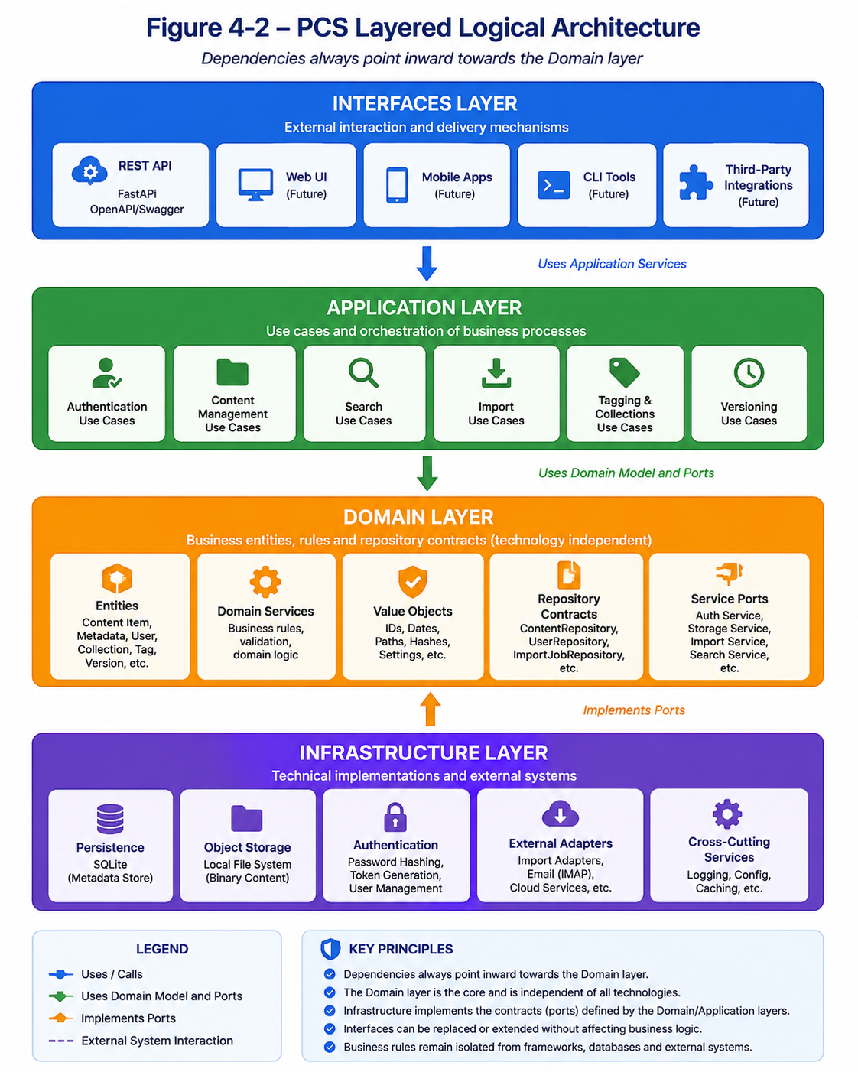
(with Infrastructure implementing ports defined by the Domain/Application layers, rather than depending on them conceptually).
Together, these two diagrams will provide readers with an immediate understanding of both the system boundary and the internal architectural organisation, making the rest of the document significantly easier to follow.

Remaining Chapters (planned)
- Architectural Principles
- Technology Stack
- Architectural Views
- Domain Model
- Persistence
- External Import
- Security
- Testing
- Operational Architecture
- Future Evolution
- Appendices

